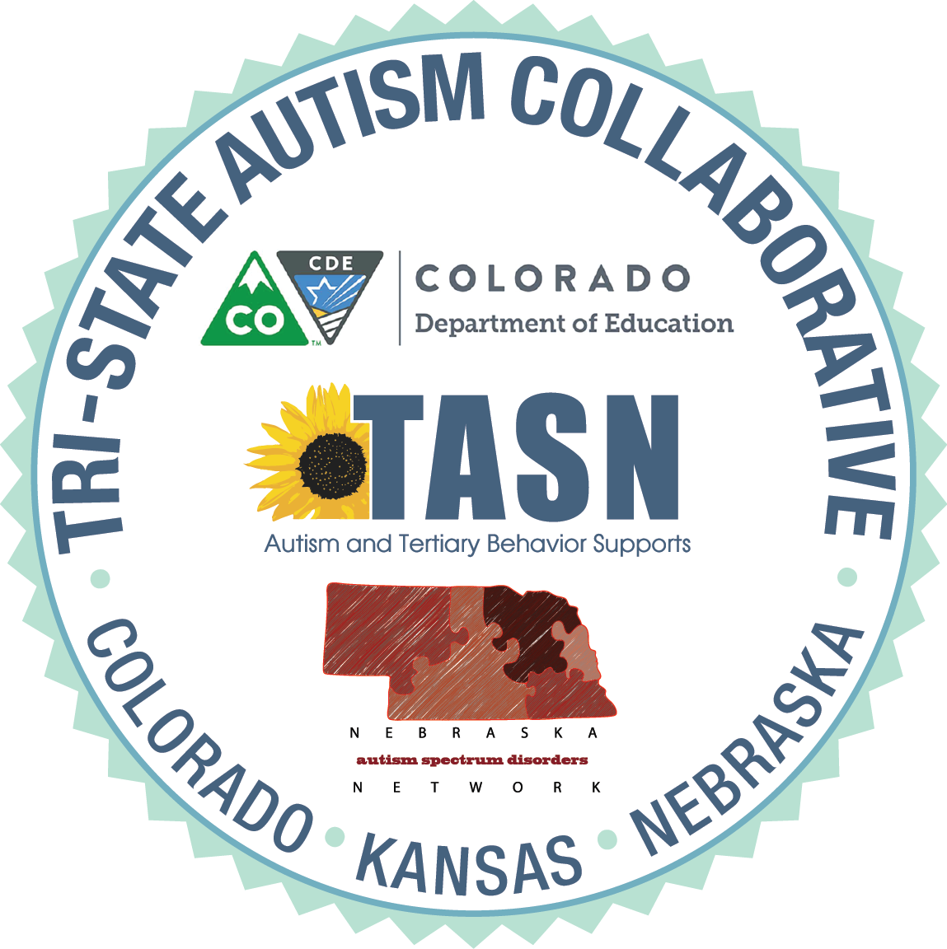

LEARNER OBJECTIVES

WEBINAR – Communication, Behavior and Social Supports for Secondary Students with ASD

At the end of this webinar, participants will be able to:
- Identify several types of visual supports to use with secondary students with ASD in the areas of:
  - Social skills
  - Communication
  - Behavior

